# FROM RED TO GREY: REVISITING THE PEDERSEN PROCESS TO ACHIEVE HOLISTIC BAUXITE ORE UTILISATION

Michail VAFEIAS1, Danai MARINOS1, Dimitrios PANIAS1, Jafar SAFARIAN2, Casper VAN DER EIJK3, Ingeborg SOLHEIM3, Efthymios BALOMENOS1, Michal KSIAZEK3, Panagiotis DAVRIS1

1 NTUA (National Technical University of Athens), Laboratory of Metallurgy, Athens, Greece

2 Norwegian University of Science and Technology (NTNU), Department of Materials Science and Engineering, Trondheim, Norway

3 SINTEF Materials and Chemistry, N-7465 Trondheim, Norway

4 Mytilineos S.A. – Metallurgy Business Unit, Aluminium of Greece Plant, Viotia, Greece

michalisvafeias@ntua.gr, dmarinou@metal.ntua.gr, panias@metal.ntua.gr, jafar.safarian@ntnu.no, casper.eijk@sintef.no, ingeborg.solheim@sintef.no, efthymios.balomenos-external@alhellas.gr, michal.ksiazek@sintef.no, panosdavris@metal.ntua.gr

## Abstract

The Pedersen Process is an alternative process for the production of alumina. Initially, bauxite ores, or other aluminous materials, are smelted with lime and fluxes to produce pig iron and a slag of mainly calcium aluminate composition. The latter is subsequently leached in Na2CO3 solutions to extract alumina. The solid slag residue from the leaching stage is a mixture consisting mainly of calcium carbonate and Ca-Si-TI phases, called Grey Mud. Compared to Red Mud, it is of low alkalinity and contains no iron. Its high calcium renders it suitable for use as a raw material in the cement industry or as a soil additive in agriculture. In addition, depending on the initial bauxite composition, grey mud could also be further leached for the extraction of valuable trace elements, such Rare Earth Elements (REEs) and Sc.

## Introduction

It had been known before the 1920s that alumina could be extracted from alkaline earth aluminates, a fact that could potentially lead to the exploitation of various low grade ores of aluminium (i.e., low grade bauxites, clays, etc.). Around that time, Norwegian Professor Harald Pedersen was doing extensive work on leaching slags of calcium aluminate composition, produced by melting bauxite, iron ore, lime and coke in electric furnace. 1 The results of these experiments were formulated in what is now known as “The Pedersen Process” for the production of alumina, which found industrial application in Norway from 1928 to 1969, with an annual production of 17,000 metric tons of alumina.2 The main product of the Pedersen Process is alumina. Nevertheless, of equal importance are the by-product of the leaching circuit, the solid residue of the leached slag, called Grey Mud. It is stripped off all Fe-oxides and is of low alkalinity. Thus it constitutes a by-product with many potential uses. The Pedersen Process presents the potential for holistic utilization of bauxite with a corresponding elimination of the Red Mud production issue. The ENSUREAL Project aims at revisiting the Pedersen Process and assess its potential implementation in the 21st century.

## Grey Mud Production in the Pedersen Process

A flowsheet of the Pedersen Process is presented in Figure 1. Raw materials for the leaching circuit are, the calcium aluminate slag, originating from the smelting stage and a dilute sodium carbonate solution, introduced as the leaching solution. On the whole, during the leaching stage, the calcium aluminate compounds of the slag react with the sodium carbonate in solution to form soluble sodium aluminate and a solid calcium carbonate precipitate. The latter, along with the non-soluble constituents of the slag, form the leaching residue, i.e. the Grey Mud.3

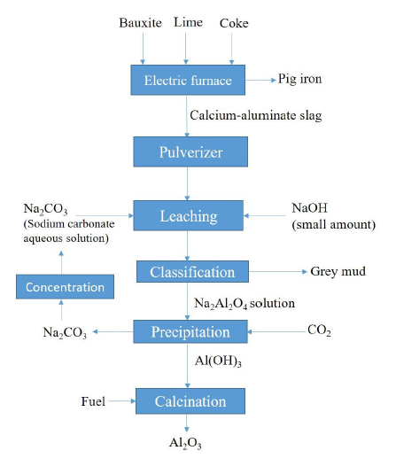

**Figure 1:** Flowsheet of the Pedersen process (after Safarian & Kolbeinsen, 2016).

Therefore, the original composition of the slag and the modelling of the leaching process are the main factors affecting the properties of the Grey Mud produced.

## Calcium Aluminate Slag Influence

Modelling the mineralogical composition of the slag produced during the smelting stage is one of the most challenging aspects of the Pedersen Process, as a typical bauxite contains several compounds, most of them are minerals,. During smelting virtually all of the Fe-content of the bauxite is reduced to metallic iron. Lime is added to the furnace mix essentially for the formation of calcium aluminates, silicates and titanates, which constitute the main slag phases. In any case, the dominant oxides in the slag phase are Al2O3, CaO and SiO2. On the assumption that TiO2 reacts with lime to form calcium titanate (CaO∙TiO2) and the small amounts of this compound have a minor effect on the phase boundaries in the phase diagram for the SiO2-CaO-Al2O3 system, then, upon equilibrium cooling, the cross-hatched area shown in Figure 2 should contain the compositions that produce the leachable calcium aluminates CaO∙Al2O3 and 12CaO∙7Al2O3.

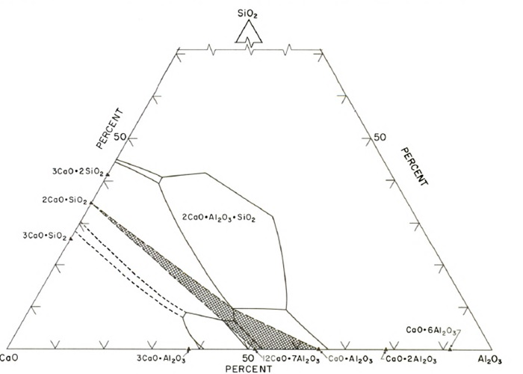

**Figure 2:** SiO2-CaO-Al2O3 phase diagram with desired slag compositions.

Besides for obtaining the most favourable calcium aluminates in terms of leachability, modelling the slag composition is important for one more reason. It is desirable for the silica content of the slag to be obtained in the form of the dicalcium silicate phase (2CaO∙SiO2). There are two reasons for this.

**Table 1:** Bauxite constituents and corresponding desirable products in the smelting stage.

|  |  |  |  |
| --- | --- | --- | --- |
| Bauxite Compound | Desirable Compound after Smelting | Furnace Phase | Found in Grey Mud |
| Fe2O3 | Metallic Fe | Pig Iron | No |
| Al2O3 | CaO∙Al2O3, 12CaO∙7Al2O3 | Slag | No |
| SiO2 | 2CaO∙SiO2 | Slag | No |
| TiO2 | CaO∙TiO2 | Slag | Yes |
| Minor Components | Insoluble compounds | Slag | Yes |

Firstly, this mineral undergoes several phase transformations from one polymorph to another when the slag is cooled. As the athermal transformation of the monoclinic β-polymorph to the orthorhombic γ-polymorph at around 675oC is accompanied by a volume expansion of about 12%,4 high internal stresses are built up in the slag, finally causing its disintegration. This phenomenon, called “dusting”, is desirable for economic reasons related to the subsequent comminution processes. Table 1 presents the correlation between compounds present in bauxite and the desirable products of these after a successfully completed smelting stage.

### Leaching Process Influence

Assuming the smelting stage has been modelled to high precision, then a calcium aluminate slag containing the desirable compounds presented in Table 1 is fed to the leaching circuit. During leaching with sodium carbonate solutions, the following reactions may take place:

$${\left(CaO∙{Al}_{2}O_{3}\right)}_{s}+{\left({Na}_{2}{CO}_{3}\right)}_{aq}→{\left(NaAl{\left(OH\right)}_{4}\right)}_{aq}+{\left(Ca{CO}_{3}\right)}_{s} (1)$$

$${\left(3CaO∙{Al}_{2}O_{3}\right)}_{s}+3{\left({Na}_{2}{CO}_{3}\right)}_{aq}+2H_{2}O→{\left(NaAl{\left(OH\right)}_{4}\right)}_{aq}+3{\left(Ca{CO}_{3}\right)}_{s}+4NaOH (2)$$

$${\left(12CaO∙7{Al}_{2}O_{3}\right)}_{s}+12{\left({Na}_{2}{CO}_{3}\right)}_{aq}+5H_{2}O→7{\left(NaAl{\left(OH\right)}_{4}\right)}_{aq}+12{\left(Ca{CO}_{3}\right)}_{s}+10NaOH (3)$$

$${\left(2CaO∙SiO_{2}\right)}_{s}+2{\left({Na}_{2}{CO}_{3}\right)}_{aq}+H_{2}O→{\left({Na}_{2}SiO_{3}\right)}_{aq}+2{\left(Ca{CO}_{3}\right)}_{s}+2NaOH (4)$$

It is evident that the primary precipitate of the leaching process is calcium carbonate (CaCO3), which is expected to be the main phase present in the Grey Mud. Due to the complex chemistry of the process, some small amounts of Ca(OH)2 and mixed silica-alumina-sodium precipitates might also be present.

## Comparison of Grey Mud to Red Mud

A comparison between the Grey Mud of the Pedersen Process and the Red Mud of the Bayer Process reflects the fundamental differences of these processes.

In terms of composition, it has already been mentioned that the main ingredient of Grey Mud is the calcium carbonate. As the leaching process can never lead to complete extraction of the alumina from the slag, a portion of unreacted alumina, silica and calcia is certainly to be present in Grey Mud. Along with these components, the insoluble compounds of the slag and some minor soda losses are to be expected. A theoretically estimated composition of a typical Grey Mud is presented in Figure 3 (actual percentages may vary depending on the composition of the initial bauxite).

In comparison with a typical Red Mud, which dominant components are Fe- and Al-oxides, there is virtually no iron present in the Grey Mud. In addition the alumina and sodium losses are expected to be lower. In terms of production, Grey Mud is expected to be produced in large quantities at an industrial scale. Data from the industrial operations at the plant in Norway suggest that the amount of Grey Mud produced was to two times as much as that of alumina produced. Red Mud production on the other hand is usually of equal amount to the alumina produced in a typical Bayer plant.5

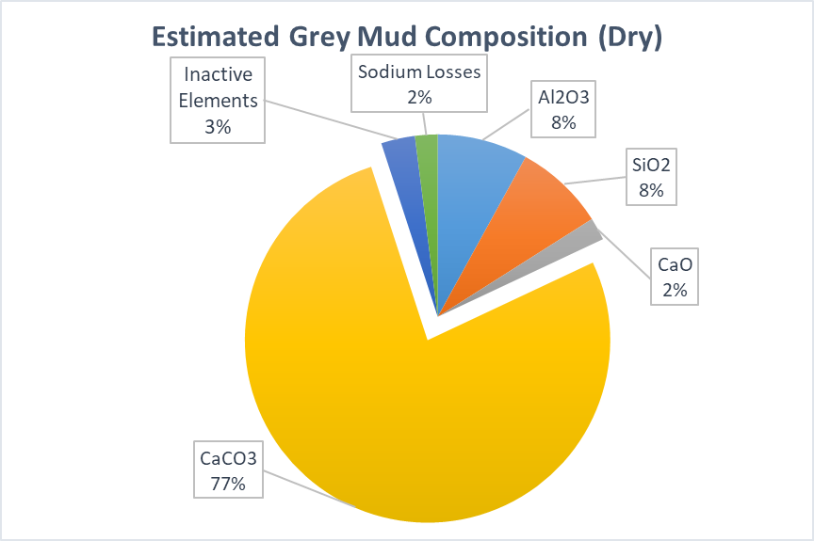

**Figure 3:** Theoretical estimation of composition of a typical Grey Mud.

The massive production of Grey Mud however didn’t cause any environmental concerns and was safely disposed, as it was of low alkalinity and practically inert. This, of course, is not the case with the Red Mud, which has to be properly washed and dewatered, before being dry stacked at a suitable storage site. These points are summarised in Table 2.

**Table 2:** Grey Mud and Red Mud Fundamental Properties

|  |  |  |
| --- | --- | --- |
|  | Grey Mud | Red Mud |
| Main Components | CaCO3, Al2O3, SiO2 | Fe-Oxides, Al2O3, SiO2 |
| Alumina Losses | Low | Moderate |
| Soda Losses | Low | Low to Moderate |
| Mud : Alumina | 2:1 | 1:1 |
| Alkalinity | Low | High |

## Potential for Grey Mud Valorisation

Its massive production and calcium based composition suggest that Grey Mud could be directly valorised. An important task of the ENSUREAL project is to assess possible valorisation routes. Research will be directed towards the following areas:

* **Agriculture/Construction sector/High added value applications:** Suitability of for these applications will be assessed.
* **Industrial use/reuse:** Decomposing Grey Mud to lime and CO2 could lower lime and CO2 costs for an industrial application.
* **REE’s extraction:** Grey Mud, under specific conditions, could be regarded as a secondary REE’s resource. Greek Bauxites present this potential.

### The Greek Bauxite Case: Grey Mud as REEs Source

REE’s concentration in Greek Bauxite ore and Bauxite Residue produced has been found to be fairly constant with only 8% variation over a period of 15 years indicating a reliable secondary REE’s resource. For this reason, there is vivid and ongoing work undertaken in NTUA, in cooperation with the Aluminium of Greece for the utilization of Red Mud from Greek bauxites as REE’s source.6 REE’s extraction by direct hydrometallurgical treatment or combined pyro-hydrometallurgical treatment from Bauxite residue has been thoroughly studied.7 Mineral acid leaching provides high recovery yields but in many cases large concentration of co-dissolved metals interfere with the downstream REE’s purification process. Furthermore, during slag leaching with alkaline solutions REE’s remain unaffected and accumulate in the residue which in this case resembles grey mud. These findings indicate that the generated grey mud from Pedersen process is expected to have substantially increased REE’s concentration compared to the initial feeding material, and to be depleted from main elements such as Fe and Al. Therefore during leaching of grey mud a significant barrier of large impurity co-dissolution can be confined. REE’s extraction from grey mud can have a significant impact on European REE supply8 as well as decreasing waste produce from the described process.

**Acknowledgments**

The research leading to these results has been performed within the ENSUREAL project (<https://www.ensureal.com>) and received funding from the European Community's Horizon 2020 Programme (H2020/2017-2021) under grant agreement n° 767533. Danai Marinos is supported by the General Secretariat for Research and Technology (GSRT) and the Hellenic Foundation for Research and Innovation (HFRI).

## References

1. H. Pedersen, “Process of manufacturing aluminium hydroxide”. United States of America Patent 1,618,105, 15 February 1927.
2. J. Miller and A. Irgens, “Alumina Production by the Pedersen Process - History and Future,” Essential Readings in Light Metals, 1. Alumina and Bauxite, pp. 977-982, 2013.
3. J. Safarian and L. Kolbeinsen, “Sustainability in Alumina production from bauxite,” in Sustainable Industrial Processing Summit, Hainan, 2016.
4. Y. J. Kim, I. Nettleship and W. M. Kriven, “Phase transformations in dicalcium silicate. II. TEM studies of crystallography, microstructure and mechanisms,” Journal of the American Ceramic Society, vol. 75, no. 9, p. 2407–2419, 1992.
5. C. Klauber, M. Gräfe and G. Power, “Bauxite residue issues: II. Options for residue utilization,” Hydrometallurgy, vol. 108, p. 11–32, 2011.
6. Balomenos, E., Davris, P., Pontikes, Y., & Panias, D., Mud2Metal: Lessons Learned on the Path for Complete Utilization of Bauxite Residue Through Industrial Symbiosis. Journal of Sustainable Metallurgy, 1-10, 2016.
7. Borra, C. R., Blanpain, B., Pontikes, Y., Binnemans, K., & Van Gerven, T., Recovery of Rare Earths and Other Valuable Metals from Bauxite Residue (Red Mud): A Review. Journal of Sustainable Metallurgy, 1-22, 2016.
8. ERECON, Strengthening the European rare earths supply chain: Challenges and policy options, 2015.